Python Programming (05CS2104)
Lab Manual (2025-26)
Program: M.Sc. (Cyber Security & Cyber Law)
Semester: 1
Name of the Student: Jenil Makwana
Enrolment No.: 92600565009

INDEX

Lab | Program | Date | Remarks | Signature
1 | Python Program to Print Hello World. | 9-8-26
2 | Python program to do arithmetical operations | 9-8-26
3 | Python program to swap two variables | 9-8-26
4 | Python Program to Find the Factorial of a Number | 9-8-26
5 | Python Program to Print the Fibonacci sequence | 9-8-26
6 | Python program to print the elements of an array | 11-8-26
7 | Python program to print the largest element and smallest element in an array | 11-8-26
8 | Python program to add two matrix using array and function | 11-8-26
9 | Python program to print the sum of all elements in an array | 11-8-26
10 | Python Program to concatenate two strings | 11-8-26
11 | Python Programs to perform various operations on Strings using functions | 1-9-26
12 | Python Programs to demonstrate use of list and various functions of it | 1-9-26
13 | Python Programs to demonstrate use of tuple and various functions of it | 1-9-26
14 | Python Programs to demonstrate the use of dictionary and various functions of it | 1-9-26
15 | Python Programs to demonstrate use of various arguments which can be passed to functions | 1-9-26
16 | Python Program to demonstrate the use of class | 1-9-26
17 | Python program to demonstrate the use of methods | 1-9-26
18 | Python programs to demonstrate the use of various forms of inheritance | 1-9-26
19 | Python programs to demonstrate use of modules | 1-9-26
20 | Python programs to demonstrate the use of exception handling | 1-9-26
21 | Python programs to demonstrate the use of file handling
22 | Python Programs to demonstrate the use of various modes of files.
23 | Python programs to demonstrate the use of regular expression
24 | Python programs to demonstrate the use of database using mysql
25 | Python Program to demonstrate the use of DataFrames in python
26 | Python Programs to demonstrate different ways of creating DataFrames
27 | Python Programs to create Pie chart
28 | Python Programs to create histogram
29 | Python Programs to create bar graph
30 | Python Programs to create Line graph
31 | Python Programs to work with Python Libraries useful for Cyber security. Program to generate hash values of a string using hashlib library.
32 | Python Program using socket — Simple Port Scanner
33 | Python Program using re — Detect Emails Using Regular Expressions
34 | Python Program using os Library — Check Files in a Directory
35 | Python program for whois lookup
36 | Python program for Ping Scanner shows ip up or down

Enrollment/Roll No: 92600565009

Practical No. 1

Aim/ Objective: Python Program to Print Hello World.

Source Code:
#Name: Jenil Makwana
#Enrollment: 92600565009

#Q.1 Python Program to Print Hello World.

Print ("Hello World")

Output:
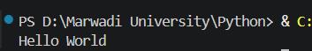

Conclusion: This program introduces the absolute foundation of Python syntax, demonstrating how to use the built-in print () function to display basic textual data directly to the console output.

Enrollment/Roll No: 92600565009

Practical No. 2

Aim/ Objective: Python program to do arithmetical operations

Source Code:
#Name: Jenil Makwana
#Enrollment: 92600565009

#Q.2 Python program to do arithmetical operations

num1 = int(input("Enter the First number: "))
num2 = int(input("Enter the Second number: "))

print ("The addition is :) ",num1+num2)
print ("The substraction is :) ",num1-num2)
print ("The multiplication is :) ",num1/num2)
print ("The division is :) ",num1*num2)
print ("The modulus is :) ",num1%num2)

Output:
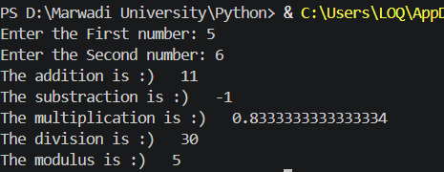

Conclusion: This script shows how Python handles math using standard arithmetic operators (+, -, *, /) to calculate values and store numerical results inside basic variables.

Enrollment/Roll No: 92600565009

Practical No. 3

Aim/ Objective: Python program to swap two variables

Source Code:
#Name: Jenil Makwana
#Enrollment: 92600565009

#Q.3 Python program to Swap two variables

num1 = int(input("Enter the 1st number: "))
num2 = int(input("Enter the 2nd number: "))

print (f"before swapping the values are num1: {num1} num2: {num2}")

num1,num2=num2,num1

print (f"After swapping the values are num1: {num1} num2: {num2}")

Output:
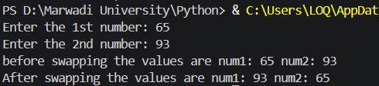

Conclusion: This problem teaches logic and memory storage by showing why a tracking variable (temp) is needed to safely trade values between two data locations without overwriting them.

Enrollment/Roll No: 92600565009

Practical No. 4

Aim/ Objective: Python Program to Find the Factorial of a Number

Source Code:
#Name: Jenil Makwana
#Enrollment: 92600565009

#Q.4 Python program to find factorial of number

num = int(input("Enter the number : "))

fact=1
for i in range (1,num+1):
fact *= i
print ("The factorial of given number is : ",fact)

Output:
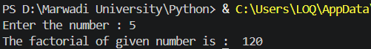

Conclusion: This code demonstrates a sequential loop calculation, showing how a single running product variable can repeatedly multiply growing numbers together to find a final mathematical total.

Enrollment/Roll No: 92600565009

Practical No. 5

Aim/ Objective: Python Program to Print the Fibonacci sequence

Source Code:
#Name: Jenil Makwana
#Enrollment: 92600565009

#Q.5 Python program to find fibonacci series

n=int(input("Enter the number: "))

a=0
b=1
for i in range (n):
a,b=b,a+b
print(a)

Output:
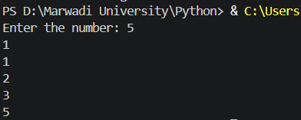

Conclusion: This exercise highlights variable updating and tracking, where two distinct numbers (a and b) pass changing values to each other dynamically to build a step-by-step sequence

Enrollment/Roll No: 92600565009

Practical No. 6

Aim/ Objective: Python program to print the elements of an array

Source Code:
#Name: Jenil Makwana
#Enrollment: 92600565009

#Q.6 Python program to print the elements of an array

arr = [10, 20, 30, 40, 50]

for i in arr:
print(i)

Output:
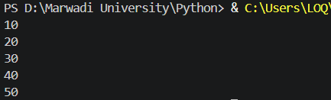

Conclusion: This script teaches array navigation, showing how a basic iterative loop sequentially unpacks a list to isolate and inspect elements one item at a time from start to finish.

Enrollment/Roll No: 92600565009

Practical No. 7

Aim/ Objective: Python program to print the largest element and smallest element in an array

Source Code:
#Name: Jenil Makwana
#Enrollment: 92600565009

#Q.7 Python program to print the largest element and smallest element in an array

arr = [23, 5, 89, 45, 12, 7]

largest = arr[0]
smallest = arr[0]

for i in arr:
if i > largest:
largest = i
if i < smallest:
smallest = i

print ("Largest element:", largest)
print ("Smallest element:", smallest)

Output:
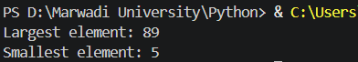

Conclusion: This program teaches conditional data filtering, using simple if comparisons inside a scanning loop to evaluate list items and track the current extreme values.

Enrollment/Roll No: 92600565009

Practical No. 8

Aim/ Objective: Python program to add two matrix using array and function

Source Code:
#Name: Jenil Makwana
#Enrollment: 92600565009

#Q.8 Python program to add two matrix using array and function

#Using array
a= [[1,2,3],[4,5,6],[7,8,9]]
b= [[9,8,7],[6,5,4],[3,2,1]]

for i in range (len (a)):
for j in range (len(a[0])):
print(a[i][j]+b[i][j], end=" ")
print ("")

#Using Function
def matrix_addition():
a= [[1,3,2],[5,4,6],[8,7,9]]
b= [[8,9,7],[4,6,5],[3,1,2]]

for i in range (len (a)):
for j in range (len(a[0])):
print(a[i][j]+b[i][j], end=" ")
print ("")

matrix_addition()

Output:
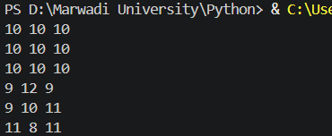

Conclusion: This structure demonstrates multi-dimensional indexing, utilizing a nested loop layout (a loop inside a loop) to target corresponding row and column intersections across distinct data grids.

Enrollment/Roll No: 92600565009

Practical No. 9

Aim/ Objective: Python program to print the sum of all elements in an array

Source Code:
#Name: Jenil Makwana
#Enrollment: 92600565009

#Q.9 Python program to print the sum of all elements in an array

arr = [10, 2, 30, 4, 50]

sum = 0

for i in arr:
sum += i

print ("Sum of all elements:",sum)

Output:
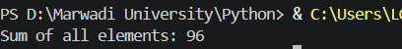

Conclusion: This problem highlights iterative value aggregation, using a linear loop to visit list elements sequentially and add their values to a single running total tracking variable.

Enrollment/Roll No: 92600565009

Practical No. 10

Aim/ Objective: Python Program to concatenate two strings

Source Code:
#Name: Jenil Makwana
#Enrollment: 92600565009

#Q.10 Python Program to concatenate two strings

s1= "hello"
s2= "world"

print(s1+" "+s2)

Output:
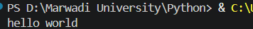

Conclusion: This logic shows how Python handles text combination, using the addition sign (+) as a simple text joining tool to merge individual pieces of string data together.

Enrollment/Roll No: 92600565009

Practical No. 11

Aim/ Objective: Python Program to demonstrate use of list and various functions of it.

Source Code:
#Name: Jenil Makwana
#Enrollment: 92600565009

#Q.11 Python Program to demonstrate use of list and various functions of it

print("Name: Jenil Makwana \n Enrollment: 92600565009")

numbers = [10, 20, 30, 40, 50]

print("The list is: ", numbers)

numbers.append(60)
print("After append: ", numbers)

numbers.insert(2, 25)
print("After insert: ", numbers)

numbers.remove(40)
print("After remove: ", numbers)

numbers.sort()
print("After sort: ", numbers)

numbers.reverse()
print("After reverse: ", numbers)

print("The length of list is: ", len(numbers))

Output:
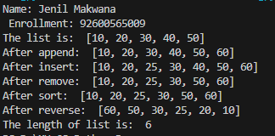

Conclusion: This logic demonstrates how Python handles lists, which are mutable data structures, using built-in functions like append(), insert(), remove(), sort(), and reverse() to actively modify and organize the stored elements.

Enrollment/Roll No: 92600565009

Practical No. 12

Aim/Objective: Python Program to demonstrate use of tuple and various functions of it.

Source Code:
#Q.12 Python Program to demonstrate use of list and various functions of it

#Name: Jenil Makwana
#Enrollment: 92600565009

#Q.12 Python Program to demonstrate use of tuple and various functions of it

print("Name: Jenil Makwana \n Enrollment: 92600565009")

numbers = (10, 20, 30, 20, 40, 50)

print("The tuple is: ", numbers)

print("The length of tuple is: ", len(numbers))

print("The count of 20 is: ", numbers.count(20))

print("The index of 30 is: ", numbers.index(30))

print("The maximum value is: ", max(numbers))

print("The minimum value is: ", min(numbers))

print("The sum of tuple is: ", sum(numbers))

Output:
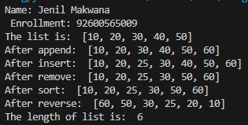

Conclusion: This logic shows how Python interacts with tuples. Since tuples are immutable, the program relies on read-only functions like count(), index(), max(), and min() to extract information and perform calculations.

Enrollment/Roll No: 92600565009

Practical No. 13

Aim/ Objective: Python Program to demonstrate the use of dictionary and various functions of it

Source Code:
#Q.13 Python Program to demonstrate the use of dictionary and various functions of it
#Name: Jenil Makwana
#Enrollment: 92600565009

print("Name: Jenil Makwana \n Enrollment: 92600565009")

student = {
"Name": "Jenil",
"Age": 22,
"Course": "MSc Cybersecurity"
}

print("The dictionary is: ", student)

print("The keys are: ", student.keys())

print("The values are: ", student.values())

print("The items are: ", student.items())

student["City"] = "Rajkot"
print("After adding City: ", student)

student.pop("Age")
print("After removing Age: ", student)

print("The length of dictionary is: ", len(student))

Output:
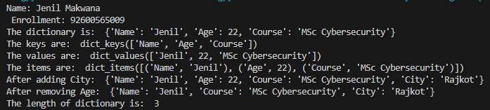

Conclusion: This program shows dictionary manipulation in Python, including accessing keys, values, and items, as well as adding and popping specific key-value pairs.

Enrollment/Roll No: 92600565009

Practical No. 14

Aim/Objective: Python Program to create a function

Source Code:
#Name: Jenil Makwana
#Enrollment: 92600565009

#Q.14 Python Program to create a function

print("Name: Jenil Makwana \n Enrollment: 92600565009")

def addition(num1, num2):
result = num1 + num2
print("The addition is: ", result)

num1 = int(input("Enter the First number: "))

num2 = int(input("Enter the Second number: "))

addition(num1, num2)

Output:
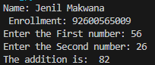

Conclusion: This logic covers the basics of modular programming in Python by defining a custom addition() function, taking dynamic user input, and performing the arithmetic block independently from the main execution flow.

Enrollment/Roll No: 92600565009

Practical No. 15

Aim/Objective: Python Program to demonstrate the use of various arguments which can be passed to functions

Source Code:
#Name: Jenil Makwana
#Enrollment: 92600565009

#Q.15 Python Program to demonstrate the use of various arguments which can be passed to functions

print("Name: Jenil Makwana \n Enrollment: 92600565009")

def student(name, age=21):
print("Student Name is: ", name)
print("Student Age is: ", age)

print("Using positional arguments:")
student("Jenil", 22)

print("Using keyword arguments:")
student(age=22, name="Rahul")

print("Using default arguments:")
student("Karan")

Output:
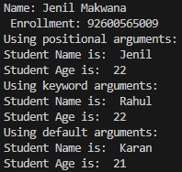

Conclusion: This logic demonstrates the flexibility of Python function parameters by successfully parsing data through standard positional arguments, explicitly mapped keyword arguments, and a fallback default argument when the user omits a parameter.

Enrollment/Roll No: 92600565009

Practical No. 16

Aim/Objective: Python Program to demonstrate the use of class

Source Code:
#Name: Jenil Makwana
#Enrollment: 92600565009

#Q.16 Python Program to demonstrate the use of class

print("Name: Jenil Makwana \n Enrollment: 92600565009")

class Student:
def display(self):
print("Student Name is: Jenil")
print("Student Course is: MSc Cybersecurity")
print("Student Age is: 22")

student1 = Student()

student1.display()

Output:
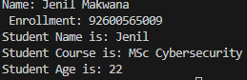

Conclusion: This logic introduces Object-Oriented Programming (OOP) in Python by encapsulating student details inside a Student class and demonstrating how to instantiate a discrete object to call the class's internal behavior.

Enrollment/Roll No: 92600565009

Practical No. 17

Aim/Objective: Python Program to demonstrate the concept of inner class

Source Code:
#Name: Jenil Makwana
#Enrollment: 92600565009

#Q.17 Python Program to demonstrate the concept of inner class

print("Name: Jenil Makwana \n Enrollment: 92600565009")

class Student:
def display(self):
print("This is the Student class")

class Address:
def display_address(self):
print("City: Rajkot")
print("Country: India")

student1 = Student()
student1.display()

address1 = student1.Address()
address1.display_address()

Output:
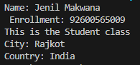

Conclusion: This logic illustrates nesting in Object-Oriented Programming by placing an Address class completely inside a Student class, showing how the inner class is dependent on the outer class namespace for instantiation.

Enrollment/Roll No: 92600565009

Practical No. 18

Aim/Objective: Python Program to demonstrate the use of methods

Source Code:
#Name: Jenil Makwana
#Enrollment: 92600565009

#Q.18 Python Program to demonstrate the use of methods

print("Name: Jenil Makwana \n Enrollment: 92600565009")

class Student:
def display(self):
print("Student Name is: Jenil")
print("Student Course is: MSc Cybersecurity")

student1 = Student()

student1.display()

Output:
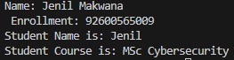

Conclusion: This logic serves as a straightforward example of binding a function (method) to a class object, using the self parameter to represent the current instance of the class that is executing the code.

Enrollment/Roll No: 92600565009

Practical No. 19

Aim/Objective: Python Program to demonstrate various types of methods

Source Code:
#Name: Jenil Makwana
#Enrollment: 92600565009

#Q.19 Python Program to demonstrate various types of methods

print("Name: Jenil Makwana \n Enrollment: 92600565009")

class Student:
def instance_method(self):
print("This is an instance method")

@classmethod
def class_method(cls):
print("This is a class method")

@staticmethod
def static_method():
print("This is a static method")

student1 = Student()

student1.instance_method()

Student.class_method()

Student.static_method()

Output:
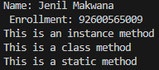

Conclusion: This logic breaks down the three distinct method scopes in Python OOP using decorators, contrasting an instance method, a @classmethod, and a @staticmethod.

Enrollment/Roll No: 92600565009

Practical No. 20(A)

Aim/Objective: Python Program to show method overloading by adding two numbers and three numbers using the same method name

Source Code:
#Name: Jenil Makwana
#Enrollment: 92600565009

#Q.20(a) Python Program to show method overloading by adding two numbers and three numbers using the same method name

print("Name: Jenil Makwana \n Enrollment: 92600565009")

class Addition:
def add(self, num1, num2, num3=0):
print("The addition is: ", num1 + num2 + num3)

addition = Addition()

addition.add(10, 20)

addition.add(10, 20, 30)

Output:
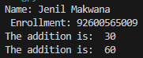

Conclusion: This logic replicates method overloading by cleverly utilizing a default argument, allowing the exact same add() method to handle varying numbers of inputs without throwing an error.

Enrollment/Roll No: 92600565009

Practical No. 20(B)

Aim/Objective: Python Program to show method overriding using a parent class Animal and a child class Dog

Source Code:
#Name: Jenil Makwana
#Enrollment: 92600565009

#Q.20(b) Python Program to show method overriding using a parent class Animal and a child class Dog

print("Name: Jenil Makwana \n Enrollment: 92600565009")

class Animal:
def sound(self):
print("Animal makes a sound")

class Dog(Animal):
def sound(self):
print("Dog barks")

animal = Animal()
animal.sound()

dog = Dog()
dog.sound()

Output:
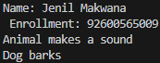

Conclusion: This logic demonstrates inheritance and polymorphism via method overriding, bro. By defining a sound() method inside the Dog child class, the program allows the child class to completely replace the parent's default behavior with its own specific output.

